5. RESULTS

5.1 Chapter overview
This chapter reports the outputs of the KnowledgeGuard prototype and the available evaluation evidence. It presents assessment and knowledge-transfer results, functional verification, expert AHP comparisons, usability and acceptance responses, and the saved machine-learning results. Collected colleague responses, generated quarterly records, and synthetic ML training profiles are treated as separate evidence sources.

5.2 Evaluation data
Five sources contributed to the evaluation. Thirty colleagues employed in industry completed a standalone Q1 assessment and supplied a start date for the tenure calculation. A separate generated dataset contained 120 records for 30 fictional identities across Q1–Q4; it was used to demonstrate imports and score history. Ten expert responses supplied AHP pairwise comparisons. Ten evaluators used the deployed prototype and completed the SUS and TAM questions. The saved ML model was trained on 500 synthetic, formula-labelled profiles.
Source | Quantity | What it can demonstrate
Standalone colleague Q1 assessments | 30 responses | Questionnaire mapping and calculation using supplied start dates
Separate generated Q1–Q4 records | 120 records for 30 fictional identities | Repeated-import and history workflow
Expert pairwise-comparison forms | 10 responses | Exploratory group AHP weights and consistency
Deployed-prototype evaluation forms | 10 responses | Descriptive SUS and TAM results
Saved synthetic ML training record | 500 generated profiles | Internal performance against formula-derived labels
Table 5.1: Evaluation sources and their permitted interpretation
The colleague responses were not joined to the fictional quarterly identities. The generated records are not longitudinal observations of those colleagues.
The retained Q1 workbook contains 30 complete responses, each with consent confirmation and a data-use acknowledgement. Applying the documented answer-to-score mapping and the current tenure rule produced mean scores of 6.53 for expertise uniqueness, 5.38 for documentation gap, 4.47 for project criticality, 4.53 for collaboration dependency, and 2.00 for tenure. Eleven records received a response-quality warning for low variation or contradiction. Using the saved ML model and the preliminary 70:30 formula/ML blend, the mean final score was 4.28; 21 records were Low and 9 were Medium, with no High or Critical records. The workbook lacks the email field required by the deployed importer, so these are independently reproduced scoring results rather than a recorded live-import audit. The separate generated Q1-Q4 dataset is not used as a substitute for these results.

5.3 Prototype outputs and workflow demonstration

5.3.1 Assessment and manager validation
The risk profile presents the five indicator values, formula score, supporting ML score, final blended score, confidence information, and risk tier. Figures 5.1 and 5.2 show the same synthetic demonstration record before and after manager validation.
Before validation, the formula score was 9.7 and the ML support score was 6.2. The preliminary calculation was:
$$R=0.70(9.7)+0.30(6.2)=8.65$$

The interface displayed 8.7/10 and classified the case as High. Although the unvalidated manager field displayed 0.0, that value was not used in the preliminary calculation. After the manager submitted validated indicator values and a note, the manager score was 10.0. The calculation became:
$$R=0.30(9.7)+0.50(10.0)+0.20(6.2)=9.15$$

The interface displayed 9.2/10 and classified the case as Critical. The comparison demonstrates how recorded managerial review changes the decision-support result. The tier does not predict that the employee will leave.
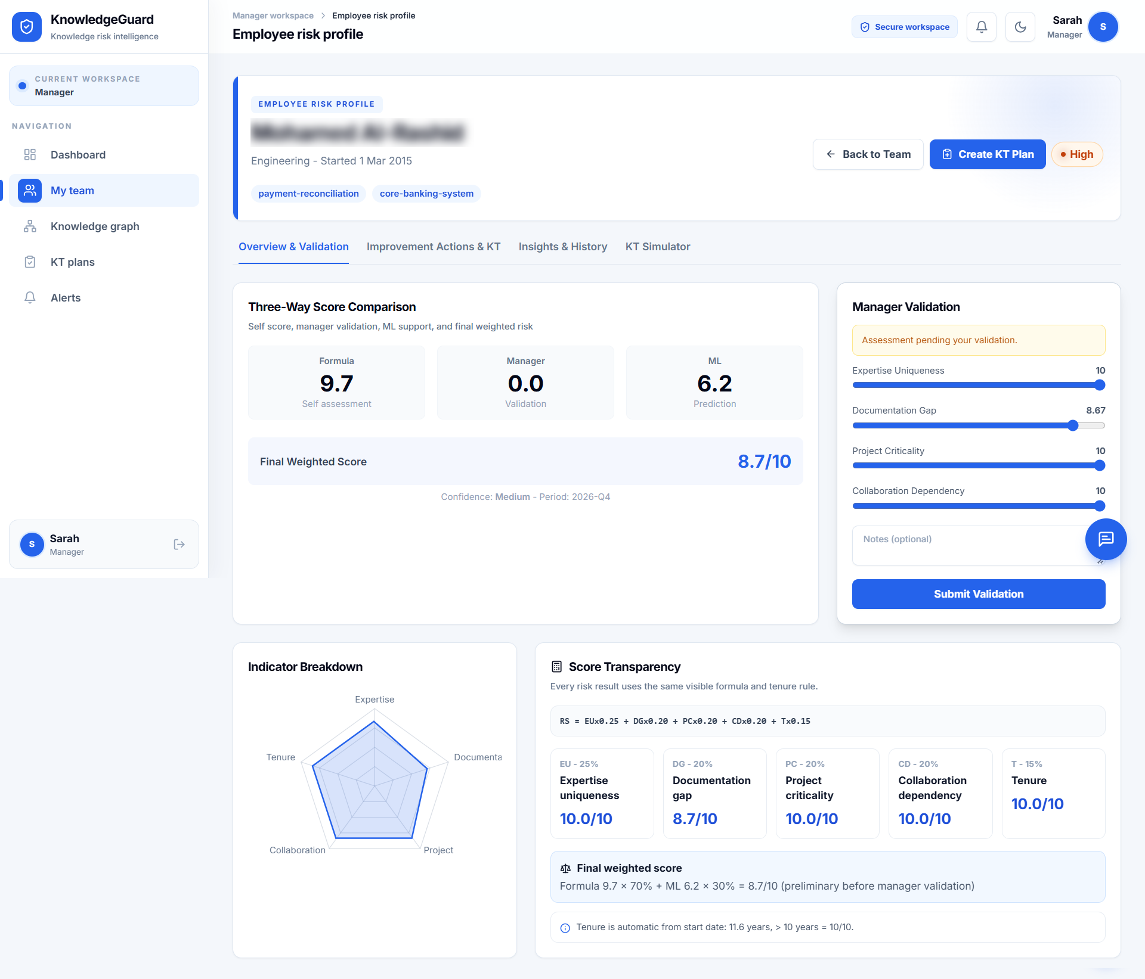
Figure 5.1: Preliminary risk profile for a synthetic demonstration record before manager validation.
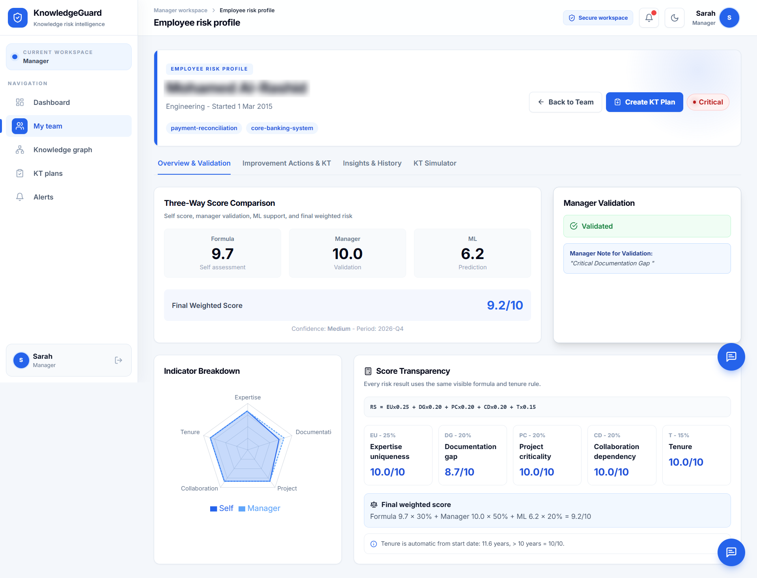Figure 5.2: The same synthetic risk profile after manager validation.

5.3.2 Knowledge-transfer planning and tasks
The implemented plan-creation route identifies the knowledge holder, proposed backup, knowledge areas, priority, and deadline. Knowledge tags guide the manager when selecting transfer areas and a suitable backup. The retained evidence demonstrates an active plan and its task sequence, but does not include a preserved creation-screen capture or an executed ineligible-backup rejection record.
For an eligible plan, the prototype creates five task types: documentation, shadowing, structured interview, backup practice and competence review, and manager sign-off. Figure 5.4 shows an active plan with these tasks pending. It demonstrates task creation, not completed transfer or successful sign-off.

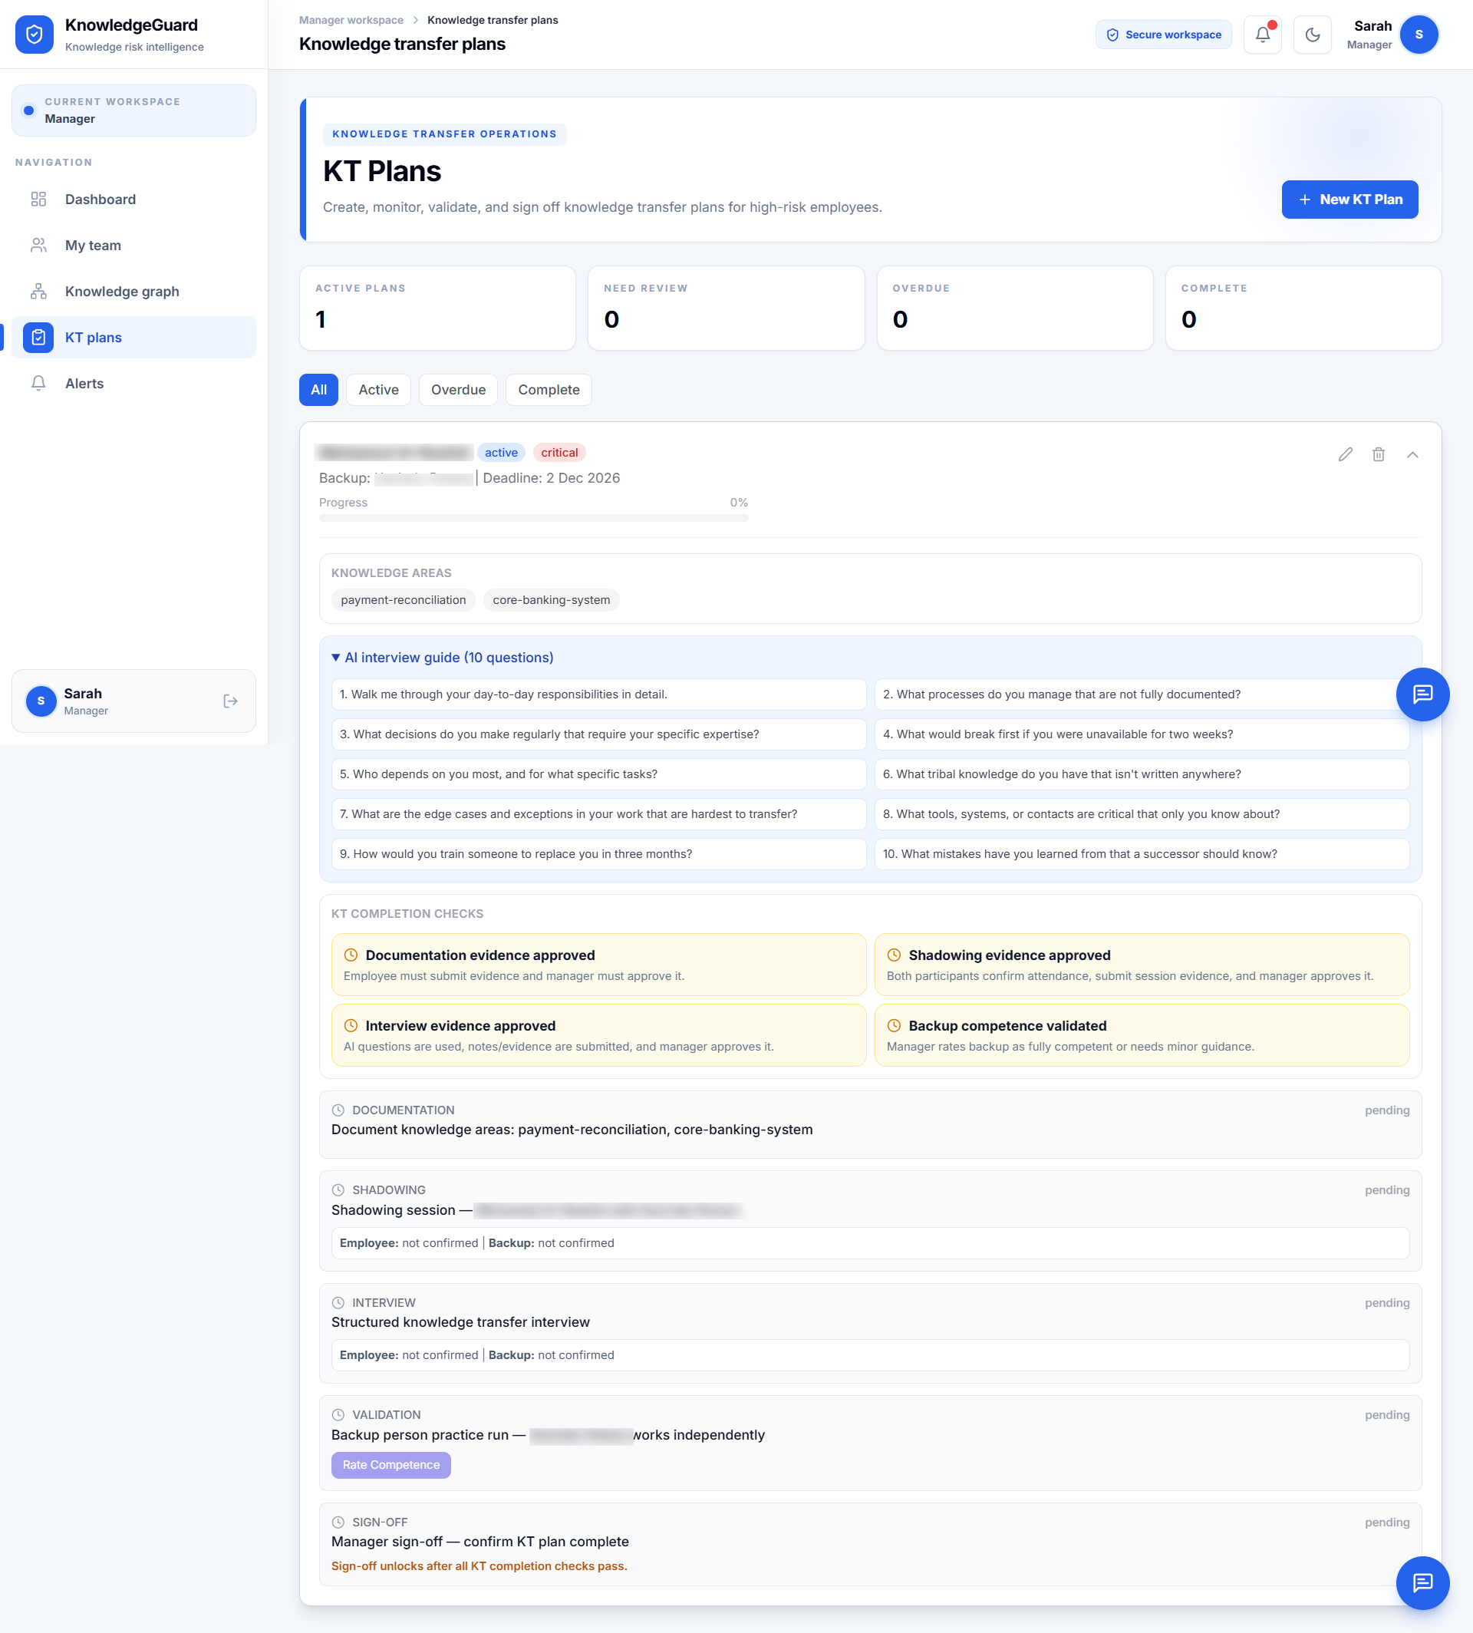
Figure 5.4: Five knowledge-transfer task types created for a synthetic demonstration plan.

5.3.3 Worked knowledge-transfer score trace
A separate arithmetic example illustrates the configured score update. It is not the employee shown in Figures 5.1 and 5.2. With EU = 9, DG = 8, PC = 9, CD = 7, and T = 10, the baseline formula produces:
$$F=0.25(9)+0.20(8)+0.20(9)+0.20(7)+0.15(10)=8.55$$
If the illustrative manager score is 8.50 and the assumed ML support score is 6.50, the validated blend is:
$$R=0.30(8.55)+0.50(8.50)+0.20(6.50)=8.115≈8.12$$

The assumed 6.50 is not a captured prediction for this example.
In a simulated completed plan, approved documentation lowers DG by 3; a fully competent backup rating lowers EU by 3; and approved shadowing and interview evidence lower CD by 2. PC and tenure remain unchanged. The updated indicator values are EU = 6, DG = 5, PC = 9, CD = 5, and T = 10, giving F = 6.80. The formula component therefore falls by 1.75 points under the configured rules. This is a rule-based system update, not a measured reduction in organizational knowledge loss. No post-sign-off final blended score is assumed because its manager and ML components must also be recalculated.
Table 5.2: Simulated knowledge-transfer score trace
Stage | EU, DG, PC, CD, T | Formula score | Interpretation
Before KT | 9, 8, 9, 7, 10 | 8.55 | Illustrative blended score: 8.12
After stipulated approved tasks | 6, 5, 9, 5, 10 | 6.80 | Configured indicator update, not measured retention
Later quarter | Requires a separate generated assessment import | Calculated from that new record | Separate workflow-history event

5.4 Functional verification and implementation evidence
Table 5.3 distinguishes visible interface outputs and executed utility tests from safeguards identified through source-code inspection. Inspection establishes that a rule exists in the current code; it does not establish that the deployed workflow passed an execution test.
Test | Expected function | Evidence currently available | Verification status
FT01 | Map Q1 answers and calculate tenure | 30 complete workbook records; documented mapping reproduced mean final score 4.28, with 21 Low and 9 Medium results | Workbook scoring reproduced; live import not run because the workbook has no email field
FT02 | Calculate preliminary score | Figure 5.1 shows formula 9.7, ML 6.2, final 8.7, and High tier | Visible interface result
FT03 | Record manager validation and recalculate | Figure 5.2 shows manager 10.0, note/status, final 9.2, and Critical tier | Visible interface result
FT04 | Reject inconsistent AHP input | Controlled CR = 0.2000 disables Apply; three AHP utility tests passed | Interface and unit-test evidence; API application test not recorded
FT05 | Reject a Low/Medium KT holder | Backend checks the holder’s latest risk tier | Implementation inspection; deployed rejection test not recorded
FT06 | Reject a High/Critical backup | Client guidance and backend latest-tier check are present | Implementation inspection; deployed rejection test not recorded
FT07 | Create five KT task types | Figure 5.4 shows the five pending stages | Visible interface result
FT08 | Block early sign-off and permit valid sign-off | Prerequisite and mitigation rules identified in code | Implementation inspection; end-to-end sign-off test not recorded
FT09 | Continue assessment when ML is unavailable | Code substitutes the formula score for an unavailable ML result | Implementation inspection; controlled ML-outage test not recorded
FT10 | Require confirmation for a manager chat action | Confirmation and backend checks identified in code | Implementation inspection; controlled confirmation test not recorded
FT11 | Support alerts and optional email | Alert and email paths identified in code | Implementation inspection; alert and email delivery not verified
Table 5.3: Functional verification and implementation evidence
The KT creation route checks whether the holder’s latest tier is High or Critical. It does not independently require a manager-validation flag before plan creation. Manager validation is therefore part of the intended decision process, but it should not be described as an enforced prerequisite.

5.5 AHP results
The ten expert forms used a scale in which 1 favoured the left indicator, 5 indicated equality, and 9 favoured the right indicator. Responses were converted to reciprocal pairwise ratios and aggregated using geometric means. The resulting group matrix gave λmax = 5.3682 and CR = 0.0822. As CR is below the configured 0.10 threshold, the aggregated group comparison met the consistency rule. This does not establish that each respondent was individually consistent or that the weights predict actual knowledge-loss outcomes.
Table 5.4: Predefined baseline and exploratory AHP group weights
Indicator | Baseline | Group AHP proposal | Difference
Expertise uniqueness | 25.00% | 51.77% | +26.77 percentage points
Documentation gap | 20.00% | 12.72% | −7.28 percentage points
Project criticality | 20.00% | 14.78% | −5.22 percentage points
Collaboration dependency | 20.00% | 15.05% | −4.95 percentage points
Tenure | 15.00% | 5.67% | −9.33 percentage points

The proposal places substantially more weight on expertise uniqueness than the predefined baseline. The AHP weights were not applied to the evaluated scoring scenarios. The baseline had been fixed before those demonstrations, and consistency of expert comparisons is not external validation against observed organizational outcomes. Changing weights after evaluation would also make the reported cases difficult to compare under one method. The difference is reported as an exploratory finding that warrants later sensitivity analysis and organizational review.
A sensitivity analysis under the exploratory AHP proposal was not performed because the standalone colleague Q1 export is not retained with the project. Such analysis should be reported only after the original Q1 responses are available and should be interpreted as sensitivity analysis rather than proof that either weighting scheme is correct.
A separate controlled matrix produced CR = 0.2000 and was rejected by the AHP consistency logic. This negative-control result is supported by three passing backend unit tests and five passing frontend CSV-processing tests; it is not presented as a deployed interface capture or as the ten-expert result.

5.6 Generated quarterly score history
The separate generated Q1–Q4 records demonstrate how the application stores and displays repeated assessments for fictional identities. These records are separate from the 30 standalone colleague Q1 responses. A change in generated history is a workflow demonstration, not an observed change in an employee's knowledge or organizational risk. No preserved score-history screenshot was available in the supplied evidence package.

5.7 Usability and acceptance results
Ten evaluators used the deployed prototype independently after receiving its link and the evaluation form through WhatsApp. They were asked to inspect the dashboard and a risk profile, review manager validation and KT planning, view AHP validation, and then answer the SUS and TAM questions. Their exact professional role counts and individual task completions were not recorded.
The ten SUS scores had a mean of 89.50, sample standard deviation of 3.07, and range of 85.0–95.0. These figures describe favourable perceived usability in this evaluator group; they are not a task-success rate.
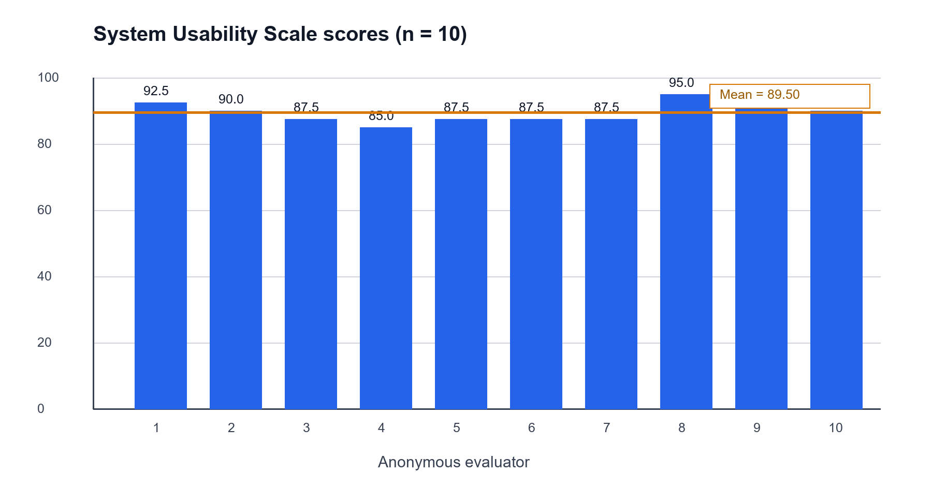
Figure 5.7: SUS results for the ten system evaluators.
The mean TAM ratings were 4.43/5 for perceived usefulness, 4.53/5 for perceived ease of use, and 4.60/5 for behavioural intention. Behavioural intention had the highest descriptive mean, although an intention rating does not establish subsequent adoption.
Measure | n | Result | What the result describes
SUS | 10 | Mean 89.50; sample SD 3.07; range 85.0–95.0 | Perceived usability in this evaluator group
Perceived usefulness | 10 | Mean 4.43/5 | Perceived value
Perceived ease of use | 10 | Mean 4.53/5 | Perceived ease
Behavioural intention | 10 | Mean 4.60/5 | Stated intention
Table 5.5: System-evaluation questionnaire summaries
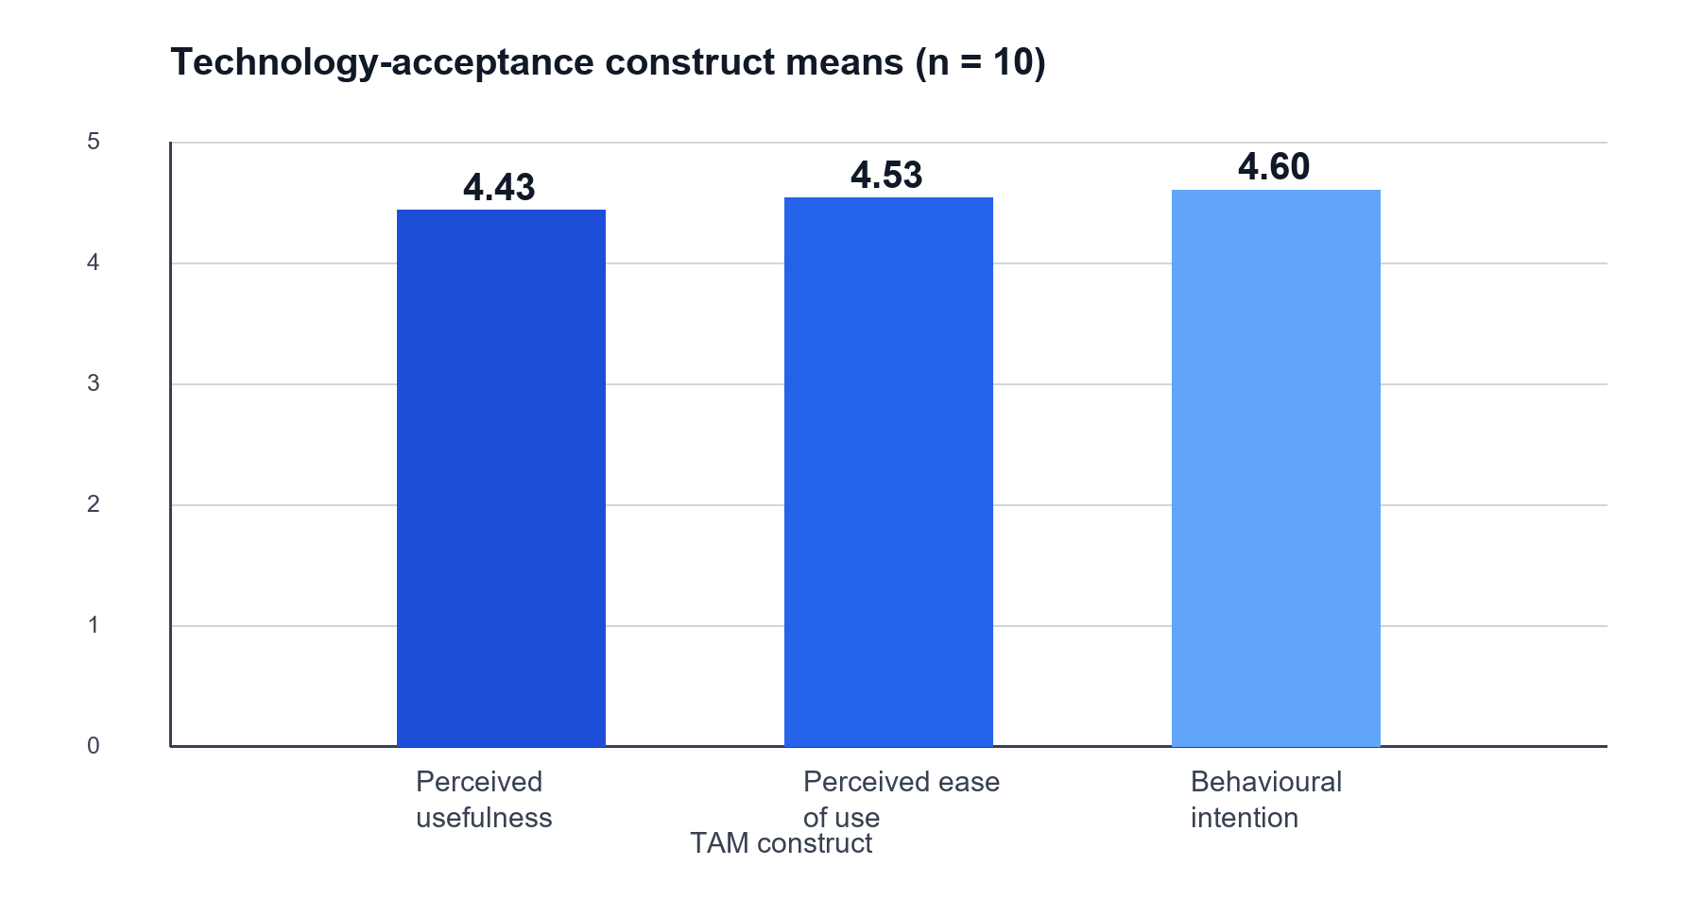
Figure 5.8: Mean TAM construct ratings from ten evaluators.

5.8 Supporting machine-learning results
The saved default model was trained on 500 synthetic profiles labelled from the baseline formula. Its saved training accuracy was 0.9780, weighted F1 was 0.9781, and mean five-fold stratified cross-validation F1 was 0.8526 with standard deviation 0.0487. Cross-validation better describes performance across the generated-data folds than training accuracy, but neither result measures prediction of real departures or knowledge retention.
Saved measure | Value | Interpretation
Training accuracy | 0.9780 | Fit to synthetic, formula-derived labels
Weighted F1 | 0.9781 | Performance in the same synthetic-label setting
Cross-validation F1 | 0.8526 ± 0.0487 | Variation across generated-data folds
Represented classes | Low, Medium, High | No Critical examples in the saved model
Table 5.6: Saved ML metrics and interpretation
The service converts class probabilities into an ML support score using fixed values: Low = 1.5, Medium = 4.3, High = 6.5, and Critical = 8.8. These conversion values are not the operational tier thresholds used for the final blended score. In particular, the value 6.5 assigned to the ML High class falls below the operational High threshold of 7.5. Because the saved model contains no Critical class, its ML score cannot exceed 6.5. This helps explain why a record with formula score 9.7 can receive ML support score 6.2. It also means the current ML component can dampen high-risk blended scores; that scale should be recalibrated in future evaluation.
The application provides a route to retrain using manager-validated assessment records from more than one tier. The reported saved model was not trained on those records. Manager-assigned labels would still require comparison with independently observed outcomes before predictive validity could be claimed.

5.9 Results against the objectives
Objective | Result supported by the available evidence
O1 — Identify indicators and develop assessment with response-quality checking | Five indicators, questionnaire mapping, tenure calculation, and response-quality warnings were implemented. Thirty complete Q1 submissions are documented, but the aggregate import audit is not retained.
O2 — Examine research and use it to inform the design | The literature review informed transparent scoring, manager involvement, backup practice, and staged knowledge transfer.
O3 — Build an integrated decision-support workflow | Assessment and validation states and creation of five KT task types are visible. Several safeguards still have inspection-only rather than execution evidence, as shown in Table 5.3.
O4 — Evaluate functionality, usability, and acceptance | Selected interface outputs and AHP utility tests were verified; ten evaluators provided favourable descriptive SUS and TAM responses. Several safeguards remain supported by implementation inspection rather than recorded deployment tests, as shown in Table 5.3.
Table 5.7: Results against the Chapter 2 objectives

5.10 Chapter summary
KnowledgeGuard demonstrated a prototype workflow linking assessment, transparent scoring, manager review, and knowledge-transfer planning. The expert-group AHP matrix was consistent but proposed weights different from the baseline used throughout the evaluation. Ten evaluators gave favourable usability and acceptance ratings. The generated quarterly history, simulated KT score update, and synthetic ML metrics demonstrate defined system behaviour within their stated settings. Chapter 6 interprets these findings and the outstanding validation limits.

